**CHAPTER 1**

**INTRODUCTION**

* 1. **Background of the Study**

Unmanned Systems are devices or machines that provide important data, automatic control units and sensors for missions without human intervention. Under this system are devices that can maneuver on the field they are capable to explore. (1) Unmanned vehicles that can move on land are called unmanned ground vehicles (UGVs), vehicles that move on water are called unmanned surface vehicles (USVs) and vehicles that can maneuver on air are called unmanned aerial vehicles (UAVs).

Unmanned Surface Vehicles operate without any crew like unmanned ground vehicles. Technology developed for UGVs can be modified or not to be used to USVs. (2) It can be remote controlled or autonomous. A remote controlled USV is controlled by a human operator through communication link. An autonomous USV operates without human intervention. (3) This study focuses on a remote controlled USV.

The Philippines is an archipelagic country. The country is one of the major contributors of ocean waste. (4) Using an unmanned surface vehicle, an efficient method as a substitute for high-risk operation and collection of waste without onboard human presence is achieved.

This paper proposes to develop an unmanned surface vehicle for surface observation. The system will be capable of receiving and sending data information from devices such as cameras and sensors attached to the vehicle for image and video analysis and processing. Furthermore, wireless communication is introduced for the transmission of data from the system to the operator.

* 1. **Problem Statement**

Philippines is ranked as the third-largest source of discarded plastic that ends up in the ocean (5). This has a profound impact not only on the health of the seas, lakes and coasts but also the economy as a whole, there is a need to develop the country's marine garbage collection services. The researchers aim to develop a control system and a human-machine interface for an Unmanned Surface Vehicle that is efficient in marine waste collection which is highly modular and can be produced easily.

* 1. **Objectives of the Study**

1. To implement actuator movements for the USV's maneuvering and camera movements.
2. To design and fabricate a controller shield for the control system.
3. To integrate sensors for power, environment assessment, and USV's location.
4. To design and implement a working algorithm for wireless monitoring and control.
5. To design a software application for monitoring and control.
   1. **Significance of the Study**

The number of unmanned surface vehicle platforms are lesser compared to the number of unmanned ground and aerial vehicles but about two-thirds of the earth is covered by oceans. The Philippines is an archipelagic country and is one of the major contributors of ocean waste. The purpose of the design of an unmanned surface vehicle is to aid the collection of ocean waste by receiving and sending data without a human onboard.

Competition of some specific applications between USVs and other manned or unmanned systems are observed. Advantages of USVs can be identified as the following: (1) USVs can execute in hazardous environment than manned vehicles;(2) USVs have lower maintenance cost; (3) lesser weight of USVs are for greater maneuverability due to no crew onboard; (4)USVs have greater potential payload capacity.

* 1. **Scope and Limitations**

The USV will be remote-operated and tested in a low-rapids river.

1. Arduino Mega 2560 Microcontroller will be used in the integration of data sensors and control of different systems of the USV.
2. NeoGPS, IMU sensors will be used for attitude and position estimation.
3. Current and Voltage sensors will be used for the power monitoring
4. The USV will be powered with 12V 2-3 Cell Lipo Battery
5. RF module transceivers will be used for the wireless communication with a maximum 700m operating range.
6. MatLab GUI will be used for the software application development.
7. The USV will thrusted with 1 BLDC Motor with ESC for speed control.
   1. **Definition of Terms**

A **catamaran** is a multi-hulled watercraft featuring two parallel hulls of equal size. It is a geometry-stabilized craft, deriving its stability from its wide beam, rather than from a ballasted keel as with a monohull sailboat. Catamaran is from a Tamil word, kattumaram, which means "logs tied together".

The **Global Positioning System (GPS)** is a satellite-based navigation system made up of a network of 24 satellites placed into orbit by the U.S. Department of Defense. GPS was originally intended for military applications, but in the 1980s, the government made the system available for civilian use. GPS works in any weather conditions, anywhere in the world, 24 hours a day. There are no subscription fees or setup charges to use GPS.

A **Graphical User Interface (GUI)** is a human-computer interface that uses windows, icons and menus and which can be manipulated by a mouse instead of entering text at a command line which are accessed solely by a keyboard.

An **inertial measurement unit (IMU)** is an electronic device that measures and reports a body's specific force, angular rate, and sometimes the orientation of the body, using a combination of accelerometers, gyroscopes, and magnetometers. The data obtained can be used to derive the three special axes in any ship. **Roll** (Longitudinal/X Axis) is an imaginary line running horizontally through the length of the ship, through its center of gravity, and parallel to the waterline. A roll motion is a side-to-side or port-starboard tilting motion of the superstructure around this axis, **Pitch** (Transverse/Y Axis) is an imaginary line running horizontally across the ship and through the centre of gravity. A pitch motion is an up-or-down movement of the bow and stern of the ship, and **Yaw** (Vertical/Z Axis) is an imaginary line running vertically through the ship and through its center of gravity. A yaw motion is a side-to side movement of the bow and stern of the ship.

**Microcontroller** is an integrated chip that is often part of an embedded system. It includes a CPU, RAM, ROM, I/O ports, and timers like a standard computer, but because they are designed to execute only a single specific task to control a single system, they are much smaller and simplified so that they can include all the function required on a single chip.

A device that detects and responds to some type of input from the physical environment is called a **Sensor**. The specific input could be light, heat, motion, moisture, physical environment. The specific input could be light, heat, motion. moisture, pressure, or any one of a great number of other environmental phenomena. The output is generally a signal that is converted to human-readable display at the sensor location or transmitted electronically over a network for reading or further processing.

* 1. **Conceptual Framework**

In this research, the overall design of the system consists of two main parts: the computer and the USV. Both parts communicate with each other through wireless communication with each part consisting of different subgroups that are integrated together to perform the functions of remote-operated USV.

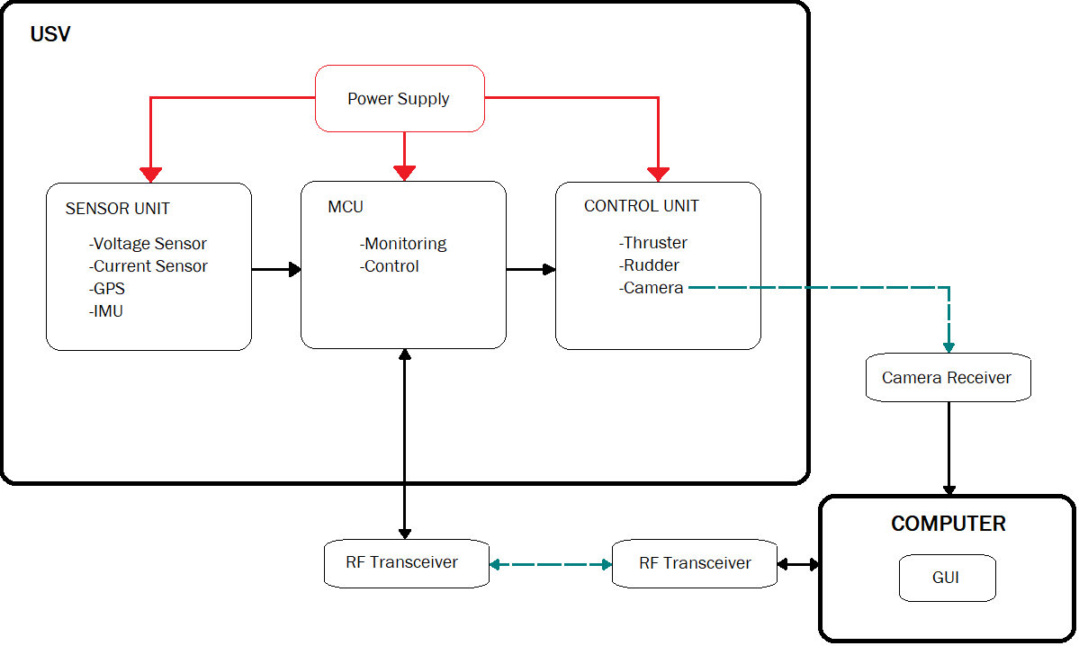

Figure 1.1 Conceptual Framework